This document is a detailed design of the watch project. we have 2 main classes.

Clock class :

attributes :

* added_hours : integer in [0..23]: the number of the total added hours
* added_minutes : integer [0..59]: the number of the total added minutes
* mode_index :integer in {0,1,2} : indicate which attribute to change (hours or minutes or none of them)
* timezone : string indicate the timezone of the clock
* timezone_difference_minutes : the difference of time in minutes between the clock’s timezone and GMT
* ligh : boolean : indicates if the light is on or off
* time_format : 24Hours or 12Hours to indicate if we want the AM/PM format or 24 hours

methods :

* run() : to be called every second to update the time in the clock
* changeMode() : To update the value of the mode
* increase() : to be called when we press increase
* increaseHours() : increase the value of added_hours
* increaseMinutes(): increase the value of added_minutes
* switchTimeFormat() : to change between the 2 time formats
* toggleLight(): to turn the light on or off
* reset() : to reset the time to it’s initial value without the edits

The Clock component is the following :

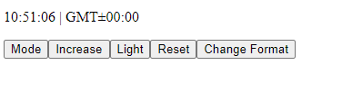

MultipleWatch class :

attributes :

* clocks : list[Clock]: contains all the clocks that we created

methods :

* addWatch() : create a new watch dynamically

The MultipleWatch component is the following :

